Made Changes to the input prompt to my initials: ZPA

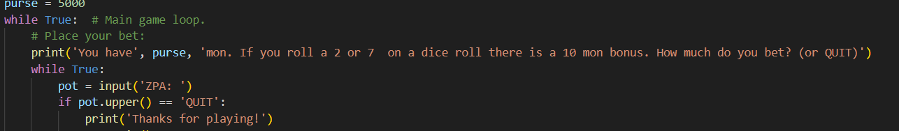

Changed house collection to 12% instead of 10%

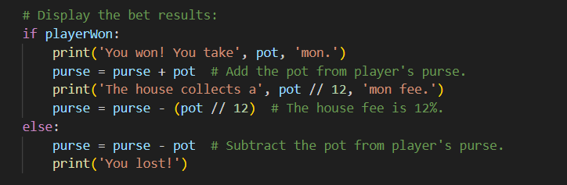

Added the 2 or 7 bonus and Message to inform user



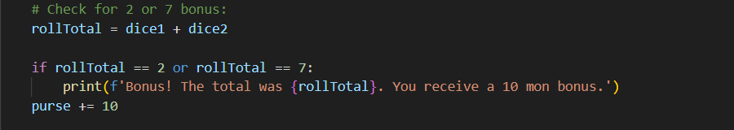

Ran the program and got the bonus!

